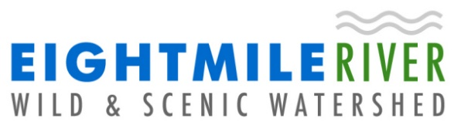
Eightmile River Wild and Scenic Coordinating Committee (ERWSCC)
Watershed Grant Program Application

Task | Time Frame
Submit application | 6 weeks prior to ERWSCC meeting
ERWSCC decision and MOU form | Within 30 days after ERWSCC meeting or receipt of additional information
Sign MOU | Within 2 weeks of receipt of MOU
Complete Project | Per conditions in MOU
Submit report and photos | Within 30 days of project completion
Reimbursement | Within 30-45 days of receipt by reimbursement request

Date: Click here to enter text.

Name of organization: Click here to enter text.

Name of responsible individual: Click here to enter text.

Address: Click here to enter text.

Email: Click here to enter text.

Phone: Click here to enter text.

For Questions 1-11 below, refer to pages 4-5 in Instructions document.

1. Location of project: Click here to enter text.

2. Project description: Click here to enter text.

3. Project deliverables: Click here to enter text.

4. Explain which and how the Funding Priority(ies) is addressed? Click here to enter text.

5. Amount requested: Click here to enter text.

6. Cost Breakdown including match amounts: (Insert table)

7. Other funding sources being applied for sought (donations): Click here to enter text.

8. Please address how the project meets the Review Criteria: Click here to enter text.

9. Dates for beginning and completion of project: Click here to enter text.

10. Other groups participating in project and number of participants: Click here to enter text.

11. Anything else we should know? Click here to enter text.

In signing this application, please note that you agree to provide a brief report and if relevant, two to three pictures within 30 days of completing the project with the understanding that ERWSCC has your permission to use the pictures and report in our material.

Authorized signature of organization (e-signature or hand): Click here to enter text.

Send to: info@eightmileriver.org Questions? Contact info@eightmileriver.org

